First version of the Instruction Dialog.

* Displays an image (or animated .gif, or video if you prefer). Currently has a single gif as these will have to be made for each set of instructions.
* Displays the text in a scrollable window beneath the image.

Sizes can be changed to suit. I feel the image should be clearer, ie either make it larger or reduce the scope of the gif to only display the single relevant button (EAT in the example).

Another idea is to have multiple “pages” of instructions which you can scroll left and right through. Each page has a specific instruction and relevant image (See below)

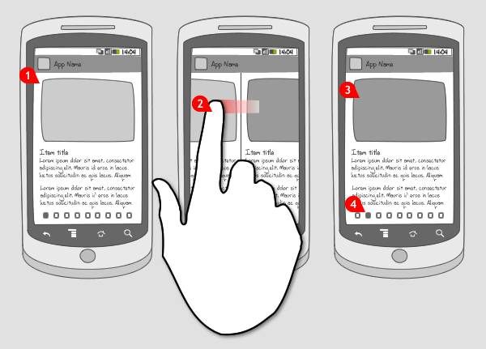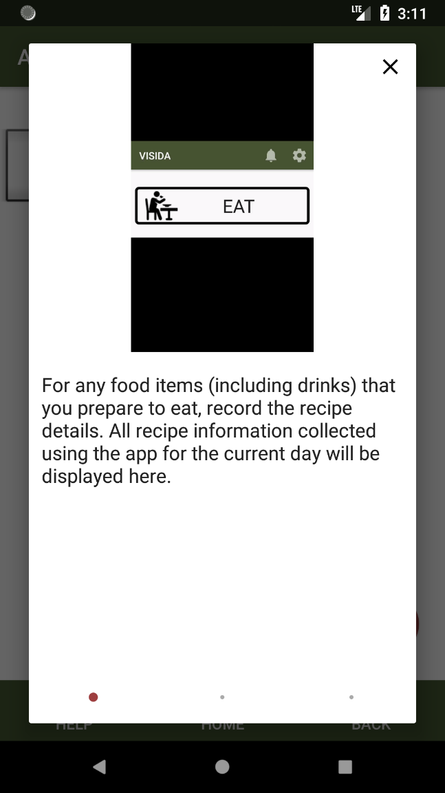

|  |  |  |  |  |
| --- | --- | --- | --- | --- |
| **Screen** | **Instruction Image (English)** | **Instruction Text English** | **Instruction Text Swahili** | **Audio File** |
| **Main Activity** |  | Select ‘**EATING’** for foods that are served on a separate plate/bowl for each person.  This might include rice or noodles.  Drinks or snacks that you eat by yourself or from your own plate can also be recorded here. |  | V1 |
|  | Select ‘**FINALIZE EATING**’ to record what happened to the food items (including drinks) you recorded using ‘OWN PLATE’ and/or ‘SHARED PLATES’ |  | V3 |
|  | Select ‘**COOK**’ for capturing ingredients and recipes of meals and snacks that you prepare. |  | V4 |
|  | Select ‘**BREASTFEED**’ if you need to record when you breastfeed for your child/ren. Note: this button will only appear if you are currently breastfeeding. |  | V5 |
|  | Select ‘HELP’ to be provided with instructions on how to complete this step |  | V6 |
|  | Select ‘HOME’ to go to the home screen of the app. |  | V7 |
|  | Select ‘BACK’ to go to previous screen |  | V8 |
|  | Select the BELL to view notifications to finalize a meal or snack |  | V9 |
| **Select Person** |  | Select the person you wish to record a meal or snack for or to finalise the meal or snack.  Only one person can be selected at one time.  If more than one person is eating at this time, you will need to repeat this step of selecting the person |  | V10 |
|  | All the members of the household will be listed.  The presence of an * after the name indicates that the person has unfinalised eating occasions.  Select the person to finalise their meal or snack. |  | V11 |
| **Eating Occasion** |  | For each person eating you will be asked to collect an image of the food and/or drinks to be consumed followed by a brief voice recording describing the contents of the image. |  | V12 |
|  | Tap ‘ADD FOOD ITEM’ to capture an image and a voice recording for meals and snacks eaten individually by one person. |  | V13 |
|  | Tap “LINK RECIPE” to link a recipe captured using the “COOK” feature. |  | V46 |
|  | Select all the Recipes which are being eaten during this eating occasion.  Tap the Audio Icon to listen to the name of the Recipe.  Tap Accept to confirm your selection or No to cancel. |  | V47 |
|  | Repeat the process for each person eating, until all foods and drinks are collected. Don’t forget to include second servings. |  | V14 |
|  | Each food item that has been captured will appear in the form of an image with an accompanying voice recording by person  Tap the audio file to play the audio recording for that image.  Tap and hold down on the image to delete the image and voice recording of the food item. |  | V15 |
|  | When you have captured all food items (including drinks) for a meal and snack, tap ‘submit’. |  | V16 |
| **ៃCamera Activity** |  | Ensure that all food items (including drinks) and the reference marker are clearly visible in the view finder. You can include more than one food or drink per image. |  | V17 |
|  | A blue cross will appear in the bottom centre of the screen. Place the reference marker in the centre and align the cross over the middle of the marker. |  | V48 |
| C:\Users\mer215\Dropbox\VISIDA\Technology\FMplacement+angle for instructions.png | Next to blue cross will be two green/red-coloured dots will appear in the bottom right hand corner. The colour of the dots will change as the angle of the phone moves.  Move the phone until both dots are green. |  | V49 |
|  | Tap the camera button to take the image. |  | V19 |
| C:\Users\mer215\AppData\Local\Microsoft\Windows\INetCache\Content.Word\review-image-capture.png | A preview of the image will appear. If you are happy with the image, tap tick.  To re-take the image tap cross. |  | V20 |
| **Record Audio** |  | For each of the food items (including drinks) included in the image, capture a voice recording to describe the following:  a) Name of item(s), including the type (e.g. red fish, snakefish)  b) any additions not clearly visible (e.g. dipping sauce).  Hold the phone close to the mouth when capturing the voice recording |  | V21 |
|  | Tap the microphone icon to start recording. |  | V22 |
|  | Tap ‘STOP’ when finished recording. |  | V23 |
|  | Tap the megaphone to playback the recording |  | V24 |
|  | To accept the voice recording, tap the green tick. |  | V25 |
|  | Tap the red cross to delete the current recording and re-record. |  | V26 |
| **Select Eating Occasion** |  | Images and voice records collected before eating on **ALL** food and drink items, including all shared dishes, will appear in the **FINALIZE EATING** section. |  | V31 |
|  | Click the Finalize button to finalize the eating occasion |  | V32 |
| **Finalize Food Item** |  | For foods and drinks collected using **OWN PLATE**  You will be asked to indicate what happened with the food and/or drink in each image that you collected BEFORE eating.  Use the buttons to indicate if you ‘ATE ALL’, ‘ATE MOST’, ‘DIDN’T EAT’  If ATE MOST (not all the food and/or drinks in the image were consumed), you will be asked to capture an image and voice recording of the leftovers. |  | V33 |
| **List Recipe** |  | For any food items (including drinks) that you prepare to eat, record the recipe details.  All recipe information collected using the app for the current day will be displayed here. |  | V37 |
|  | Tap to add a recipe information for meals and snacks that you prepare. |  | V38 |
|  | Recipes that have been captured throughout the day can be edited up until End of Day Review. Tap ‘edit’ to modify the ingredients. |  | V39 |
| **Create Recipe** |  | Tap the microphone to make a voice recording of the name of the dish or recipe.  Tap the mic to make a voice recording of the recipe name. Tap ‘stop’ when finished recording. |  | V40 |
|  | Tap ‘add ingredient’ to capture an image of the ingredients used. You can include multiple ingredients in one image. |  | V41 |
|  | Place the card next to food items (including drinks) in the bottom left-hand corner.  Ensure that all food items (including drinks) and the card are clearly visible in the view finder. Two green/red dots will appear in the top right hand corner. The colour of the dots will change as the angle of the phone moves. Move the phone until both dots are green. You can now take the image.  If you are happy with the image, tap ‘accept’. To re-take the image tap ‘cancel’. |  | V42 |
|  | Capture a voice recording to describe the name of item(s), including the type (e.g. red fish, snakefish).  Repeat steps 2-4 until all ingredients are captured. |  | V43 |
|  | Click ‘submit’ to finalise the recipe.  Capture a final image of the prepared dish. |  | V44 |
| **Breastfeed** |  | Select the person being breastfed.  Tap ‘CAPTURE’ to record a breastfeeding occasion.  The breastfeeding occasion will be recorded and the app will return to the home screen. |  | V45 |
| **Record Review** |  | Each of the Food Records Eating Occasions will be displayed.  If there were any eating occasions which were not captured click "YES" to add a voice-only record.  Please briefly describe the types and approximate amounts foods and drinks that you did not take images for at the time of eating/drinking. |  | V53 |
|  | Click the Microphone and describe any other food items you ate during the day that you did not already capture. |  | V54 |
|  | Click "NO" when finished. |  | V55 |